How to Approve/Deny a Major/Minor (Advisor’s perspective)

Step 1

Go to SF State’s home page at www.sfsu.edu and:

- Select the Login link to log into SF State Gateway/MySFSU.
- Log in with your SF State ID or E-mail and SF State Password.
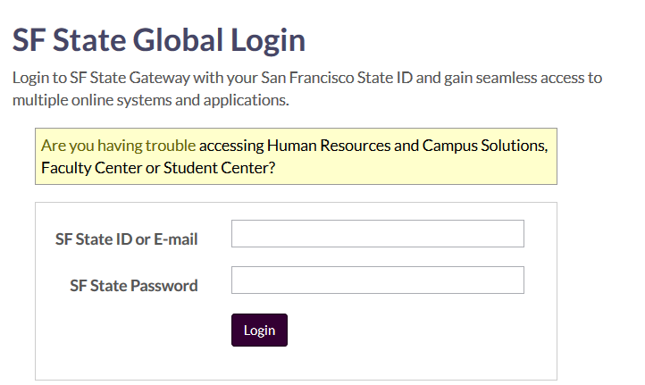

Step 2

Your SF State Gateway home page displays.

Click the Employee Services link under the Faculty/Staff section and log into CS and HR Self Service.

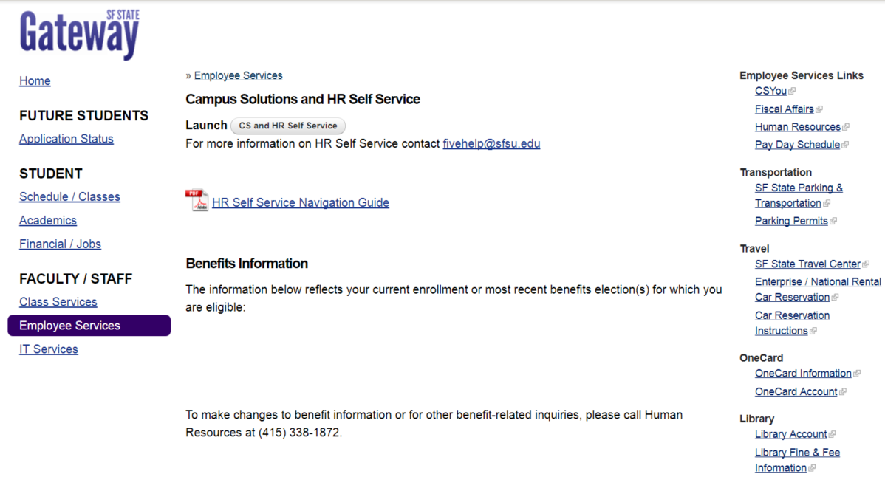

Step 3

Go to the Advisor Review search page.
- Under Menu SF State Campus Solutions Academic Advisement Major Change – Advisor Review
Advisor Review search

Step 4

The Change of Major Request Search page appears displays the record of the request(s) including:
- Transaction details (college, department, student ID, name, date and time, academic plan, description of academic plan)
- Needed action
  - N/A indicates that no action is needed, as the request has already been processed
  - Apprv/Deny indicates that the request is still outstanding
- Review/Process link to the specified request

Select the Academic Group in the drop-down menu. The available selection(s) is determined by a user’s row-level security.
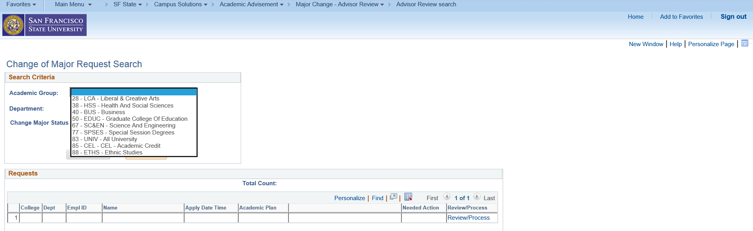

Step 5

Narrow down your search criteria by selecting Department and/or Change Major Status. Leaving it blank will return all results.

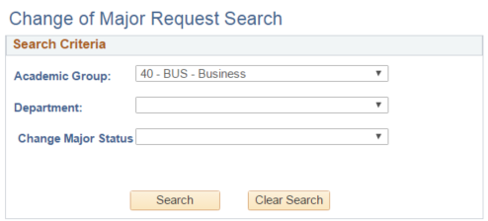

Step 6

Select an item to review by clicking on the Review/Process link.

(This advisor has selected item #7 – BUSXMKTGBS.)
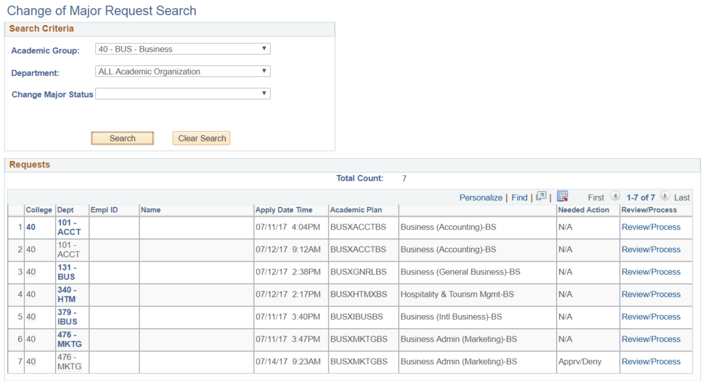

Step 7

The Change of Major Advisor Review page displays information of the request, including:
- Student ID, student name, and SF State email
- Total cumulative units, SF State GPA, Cumulative GPA, and student’s current class level
- Student’s current major/minor, current class enrollments, advisor center (all 3 links will open in new tabs)
- The major/minor and catalog year of the student’s request
- Approve, Deny, Pending action buttons
- Comments text box and the option to select whether the text displays in the student’s self-service and email
- Any change history, specifically to the requested academic plan, for the student

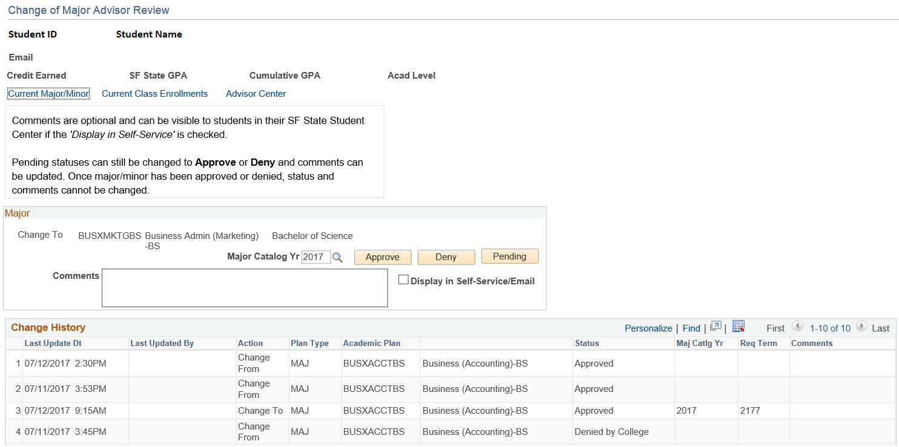

- Change Major Catalog Year – optional
By default, the major catalog year will be set with the following conditions:
- The catalog year will update when Summer term begins.
- If current semester is Winter or Spring, the catalog year will take the Fall term of undergrad from last year,
- If current semester is Summer, the catalog year will take the Fall term of undergrad from current year,
- If current semester is Fall, the catalog year will take the current fall term of undergrad.

- Input comments – optional
Important: comments, shared or not, will be part of the student’s academic record and can be subpoenaed
Tip: Comments text box is ASCII text. Hyperlinks, if used, will require students to type/copy & paste in URL address. Special characters are not recommended.

- Select whether the comment can be displayed in student’s self-service/email – optional

- Approve, Deny, Pending
If approve or deny action is selected, button will be greyed out and email notification will be sent to student.
If pending is selected, button will not grey out and email notification will be sent to the student.

Step 8

Once an action (approve, deny, pending) has been selected, students will be notified via email and status will be updated in student center.

Example of approved major/minor:

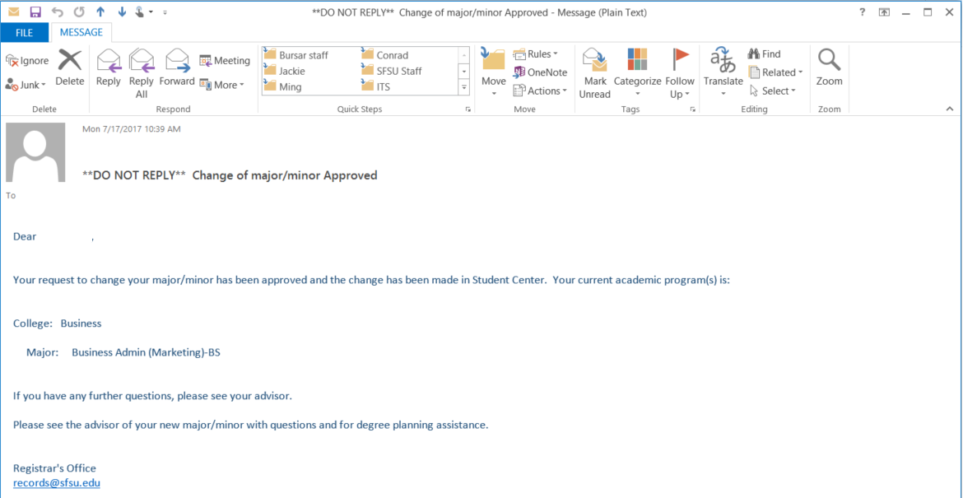

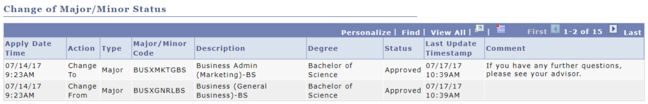

Step 9

College advisors or administrators can view a student’s Change of Major/Minor history.

Go to the Change of Major History page.
- Under Menu SF State Campus Solutions Academic Advisement Major Change – Advisor Review
Change of Major History

Step 10

The basic search criteria will be student ID, while the advanced search criteria includes student first name and last name.

Tip: If field(s) are left blank, search will return all students.

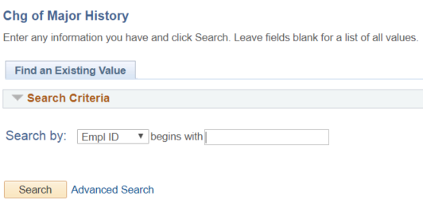

Step 11

The Change of Major History page will display all the recorded transactions for a student, which includes the following:
- Transaction details (applied date and time, action, plan type, program, academic plan, plan description, status, comments, advisor/administrator that processed the request, last update and time)

